**FINAL REPORT**

|  |  |
| --- | --- |
| Student Name/ID Number/Section | Mahmoud Rumaneh ,20120103, SECTION 1 |
| HTU Course Number and Title | **30201100: Fundamentals of Computing** |
| BTEC Unit Number and Title | **Not Available** |
| Academic Year | Fall 2020/2021 |
| Assignment Author | Eng. Malek Al-Louzi, Eng. Atheer AlShaggah, Dr. Nayef AbuAqeel, Eng. Alaa AlBakhit, and Eng. Ali Omari |
| Course Tutor | Eng. Malek Al-Louzi, Eng. Atheer AlShaggah, Dr. Nayef AbuAqeel, Eng. Alaa AlBakhit, and Eng. Ali Omari |
| Assignment Title | Intelligent **humanoid robot to support International Queen Alia Airport** |
| Assignment Ref No | **Assignment 1** |
| Issue Date | 22th December 2020 |
| Formative Assessment dates | 3rd January 2021 to 21st January 2021 |
| Submission Date | 31st January 2021 Report and Source Code Submission  6th February 2021 to 11th February 2021 Oral Assessment Period (According to your Instructor) |
| IV Name & Date | Eng. Malek Al -Louzi 21th December 2020 |

Task 1 : Flowcharts

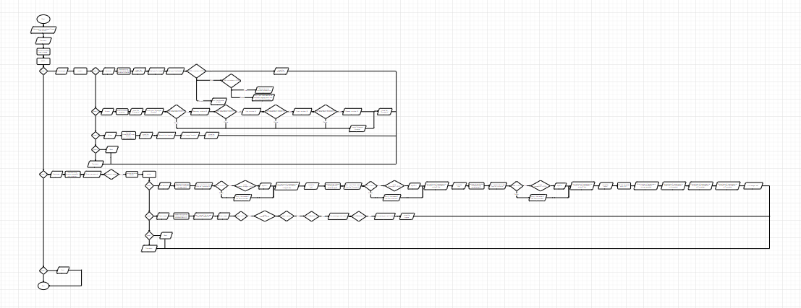

Other clear PDF will be submitted.

Task 2 & 3 screenshots:

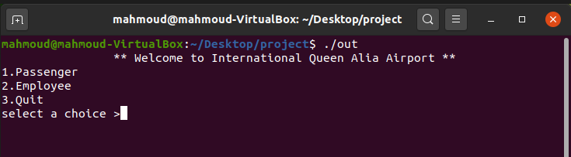

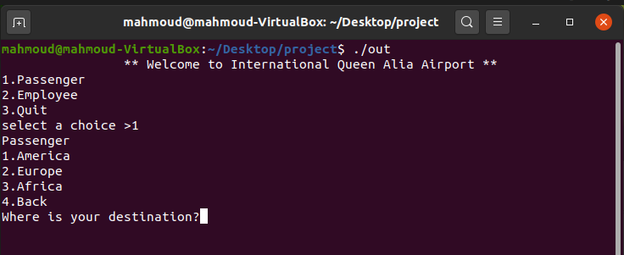

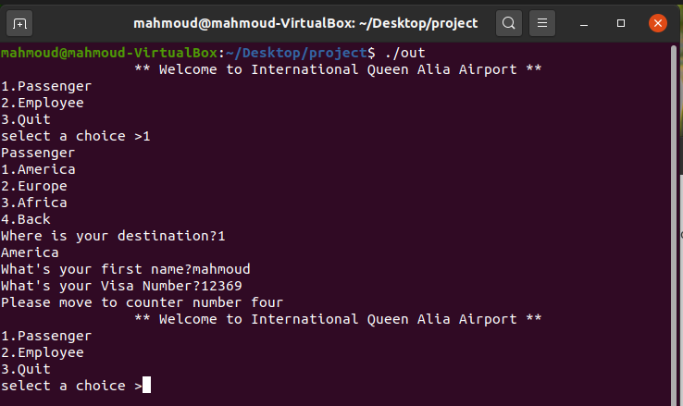

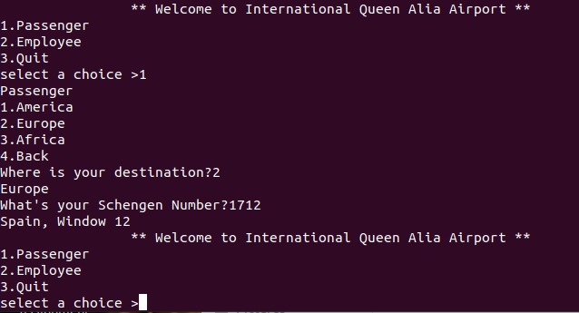

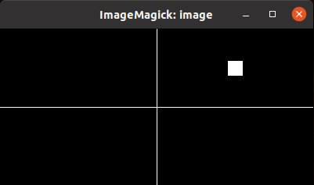

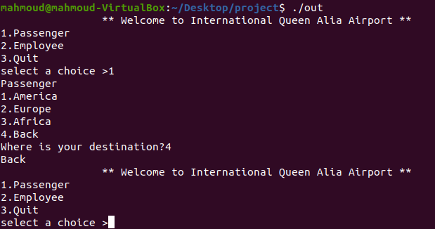

Task 4 screenshots:

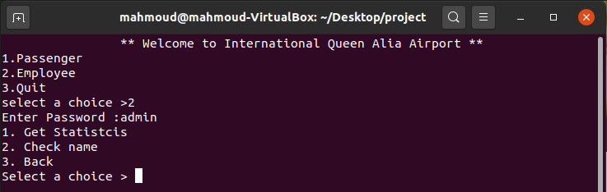

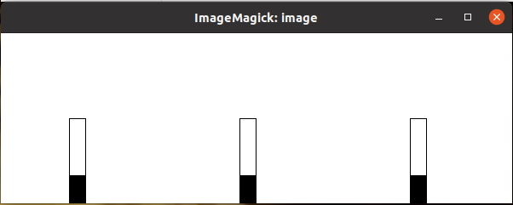

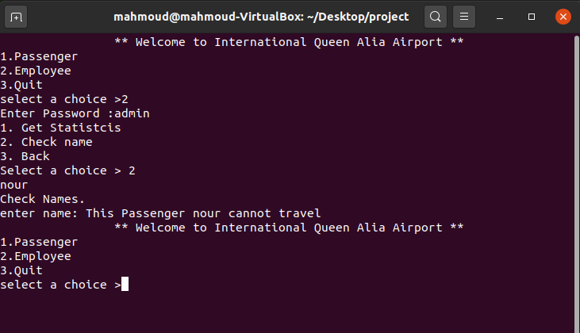

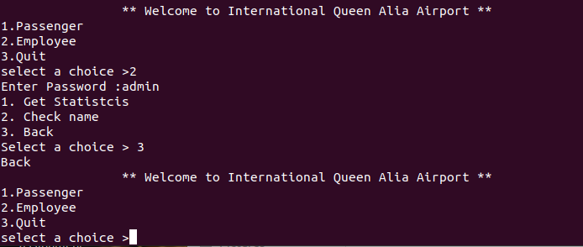

Task 5 :  
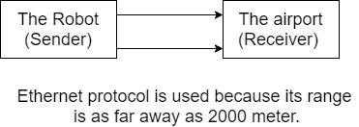

|  |  |  |
| --- | --- | --- |
| **Student name: Mahmoud Rumaneh**  **Student ID: 20120103** | | **Assessor name:**  Eng. Malek Allouzi |
| **Issue date:**  22/12/2020 | **Submission date:**  31/1 /2021 | **Submitted on:**  30/ 1 /2021 |
| **Programme:** | | |
| **HTU Course Name:** Fundamentals of Computing **BTEC UNIT Title *: NA**  **HTU Course Code:** 30201100 **BTEC UNIT Code: NA**  **I AM REPEATING THIS UNIT* : (NO)** | | |

31/1/2021

Mahmoud Rumane

**Date:**

**Student signature:**

**Student declaration**

I certify that the assignment submission is entirely my own work and I fully understand the consequences of plagiarism. I understand that making a false declaration is a form of malpractice.